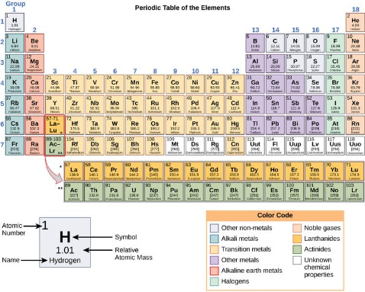
1060L

The periodic table: A classic design
By Mark Blaskovich, 01/01/2018
The periodic table is a chart commonly found hanging on the walls of science labs and classrooms. Almost everyone has seen it at some time in their life. You can also find the periodic table on T-shirts, mugs, beach towels and plenty of other items. It even inspired a collection of short stories.
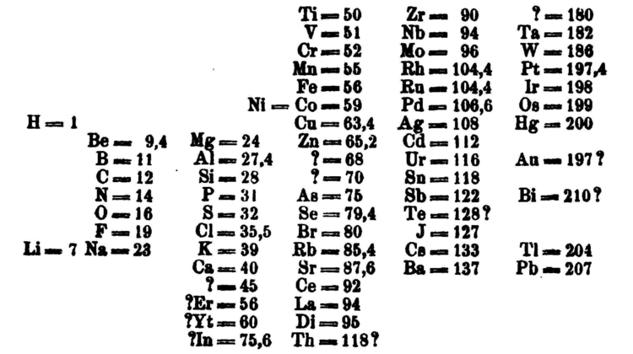
Tom Lehrer is a Harvard mathematics professor and a singer. He wrote a song called "The Elements," which includes all the elements that were known at the time of writing in 1959. Since then, several new elements have been added to the periodic table. Four new ones were formally approved in 2016.
The periodic table is an attempt to organize the collection of the elements, which are all the types of atoms that make matter.
The Elements
Scientists began collecting elements in the 1700s and 1800s. They slowly identified new ones over decades of research and began to notice patterns and similarities in their physical behavior. Some were gases, some were shiny metals, some reacted violently with water, and so on.
Scientists began to look at ways to arrange them systematically so that similar properties could be grouped together, just as someone collecting seashells might try to organize them by shape or color.
Mendeleev's periodic table. Image: Dimitri Mendeleev/Wikimedia.
However, many elements were still unknown. This left gaps that made finding patterns a bit like trying to assemble a jigsaw puzzle with missing pieces. Different scientists also came up with different types of tables. The first version of the current table was made by Russian chemistry professor Dmitri Mendeleev in 1869. Importantly, Mendeleev left gaps in the table where he thought missing elements should be placed. Over time, these gaps were filled in and the final version as we know it today emerged.
The Atoms
To really understand the design of the periodic table, we need to understand a bit about atoms. Atoms have a central core called the nucleus, made up of smaller particles called protons and neutrons. The number of protons gives an element its atomic number. This number is found in the top left corner of each box in the periodic table.
The periodic table is arranged in order of increasing atomic number (left to right, top to bottom). It ranges from element 1, or hydrogen (H) in the top left, to the newly approved element 118, called oganesson (Og) in the bottom right. Atoms of the same element with different numbers of neutrons are called isotopes.
There is a separate box of elements below the main table (and an odd shape for the main table), with a bite taken out of the top. This is because of how the other parts of an atom – the electrons – are arranged.
The Electrons
Atoms have seven layers of electrons called shells, which surround the nucleus. Each row in the periodic table corresponds to one of these shells. Each shell has subshells, which get filled in a certain order as electrons are added.
In other words, the first element in each row starts a new shell containing one electron. The last element in each row has two of the subshells in the outer shell fully occupied. Elements in the last column, such as helium and neon, are called the noble gases. They are all gases, and they are "noble" because they rarely associate with other elements.
In contrast, the elements of the first column, with the exception of hydrogen, are called alkali metals. The first-column elements are metal-like in character and very reactive. This means that under certain conditions these elements will form bonds that connect them with other elements.
Each shell can hold an increasing number of electrons. The first shell only fits two, so the first row of the periodic table has only two elements: hydrogen (H) with one electron and helium (He) with two.
The second shell fits eight electrons, so the second row of the periodic table contains eight different elements.
The third shell fits 18 electrons, but the third row still only has eight elements. This is because the extra 10 electrons don't get added to this layer until after the first two electrons are added to the fourth shell.
So the gap is expanded in the fourth row to make room for the additional 10 elements, leading to the "bite" out of the top of the table. The extra 10 elements in the middle section are called the transition metals.
The fourth shell holds 32 electrons, but again the extra electrons are not added to this shell until some have also been added to the fifth and sixth shells. Both the fourth and fifth rows hold 18 elements.
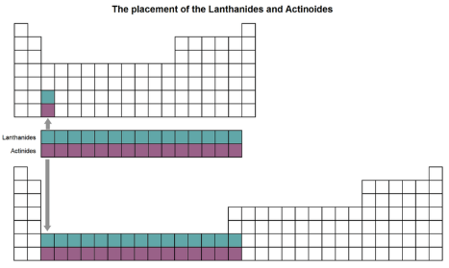
For the sixth and seventh rows, further expanding the table sideways to include these extra 14 elements would make it too wide to easily read. Instead, they have been inserted as a block of two rows below the main table.
The periodic table would look very different if the extra rows were added. Image: The Conversation.
You can see where they would fit in if the periodic table was widened. Just look at the bottom two squares in the third column of the table above.
Across The Columns
There is another complicating factor leading to the final shape of the table. As the electrons are added to each layer, they go into different subshells. Each shell has its own layout of subshells. These subshells are known by the letters s, p, d and f. These give the total number of electrons in each shell as we progress through the periodic table.
Elements within a column generally have similar properties. In some places, elements side by side can also be similar. For example, in the transition metals, the cluster of copper (Cu), silver (Ag), gold (Au), palladium (Pd) and platinum (Pt) are quite alike.
Most of the existing elements with high atomic numbers are very unstable and have never been found in nature. This includes the four super-heavy elements added in 2016. Instead, they are created and studied in tiny quantities under highly artificial conditions. Theoretically, there could be further elements beyond the 118 now known, but we don't know yet if any of these can be isolated.
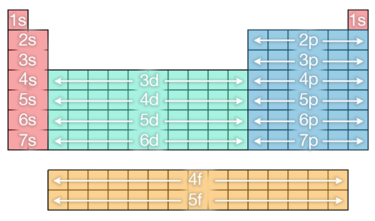
Shells indicated on the periodic table. Image: The Conversation.
A Classic Design
The periodic table has seen many colorful and informative versions created over the years. One of my favorites is an artistic version with original artworks for each element. Another is an interactive version with pictures of the elements, created by a team that has also published a coffee table book and an app with videos of each element.
The classic design of the periodic table can be used to play a version of the Battleship game. There are also fun versions created to help organize many different objects, including food, beer, emojis, iPad apps and birds. As for Tom Lehrer's song "The Elements," it has yet to be updated to include all the elements known today, but it has been covered by other people over the years.
In summary, the periodic table is the chemist's chart of all elements. It is still highly relevant to scientists, as it has become embedded in popular culture.
Mark Blaskovich is a chief researcher at the University of Queensland, Australia.

