3.3 Distinguishing Among Atoms
I. Atomic Number, Mass Number, and Isotopes
A. Atomic Number (Z)- The number of protons in the nucleus of each atom of that element
1. Atoms are identified by their atomic number.
2. Because atoms are neutral, # protons = # electrons
3. Periodic Table is in order of increasing atomic number.
B. Mass Number- The total number of protons and neutrons in the nucleus of an isotope
C. Isotopes- Atoms of the same element that have different masses
1. All atoms of the same element have the same # of protons, but may vary in the number of neutrons.
2. Although isotopes have different masses, they do not differ significantly in their chemical behavior
3. Hydrogen as an example:
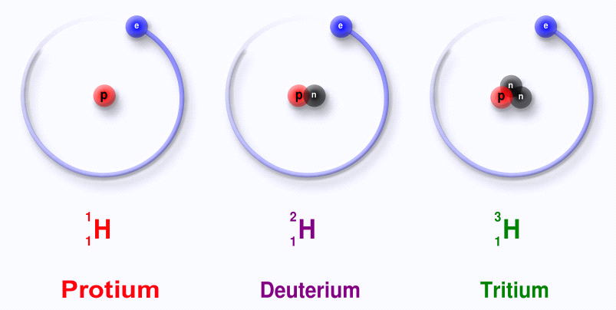

Page 52
D. Designating Isotopes
1. Hyphen notation - Mass number is written after the name of the element or chemical symbol
(a) hydrogen-2, helium-4
(b) H-2, He-4
2. Nuclear Symbol - Composition of the nucleus using the element's symbol
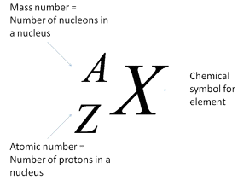 Ex. 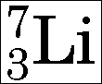

II. Using Atomic Mass
A. Average Atomic Masses - The weighted average of the atomic masses of the naturally occurring isotopes of an element
1. Atomic masses on the periodic table are average masses.
2. In calculations using atomic mass, we will round the masses to two decimal places before doing calculations.
Examples: Mg = 24.3050 we use: 24.31
O = 15.9994 we use: 16.00
N = 14.00674 we use: 14.01

