3.3 Distinguishing Among Atoms
I. Atomic Number, Mass Number, and Isotopes
A. Atomic Number (Z)- The number of protons in the nucleus of each atom of that element
1. Atoms are identified by their atomic number.
2. Because atoms are neutral, # protons = # electrons
3. Periodic Table is in order of increasing atomic number.
B. Mass Number- The total number of protons and neutrons in the nucleus of an isotope
C. Isotopes- Atoms of the same element that have different masses
1. All atoms of the same element have the same # of protons, but may vary in the number of neutrons.
2. Although isotopes have different masses, they do not differ significantly in their chemical behavior
3. Hydrogen as an example:
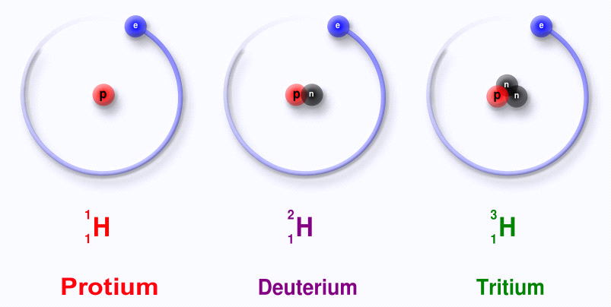

D. Designating Isotopes
1. Hyphen notation - Mass number is written after the name of the element or chemical symbol
(a) hydrogen-2, helium-4
(b) H-2, He-4
2. Nuclear Symbol - Composition of the nucleus using the element's symbol
3.3 Distinguishing Among Atoms
I. Atomic Number, Mass Number, and Isotopes
A. Atomic Number (Z)- The number of protons in the nucleus of each atom of that element
1. Atoms are identified by their atomic number.
2. Because atoms are neutral, # protons = # electrons
3. Periodic Table is in order of increasing atomic number.
B. Mass Number- The total number of protons and neutrons in the nucleus of an isotope
C. Isotopes- Atoms of the same element that have different masses
1. All atoms of the same element have the same # of protons, but may vary in the number of neutrons.
2. Although isotopes have different masses, they do not differ significantly in their chemical behavior
3. Hydrogen as an example:

D. Designating Isotopes
1. Hyphen notation - Mass number is written after the name of the element or chemical symbol
(a) hydrogen-2, helium-4
(b) H-2, He-4
2. Nuclear Symbol - Composition of the nucleus using the element's symbol

