II. The Nucleus
A. The Rutherford Experiment (1911)
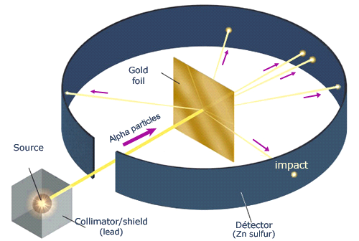1. Alpha particles (helium nuclei) fired at a thin sheet of gold.
a. Assumed that the positively charged particles were bounced back if they approached a positively charged atomic nucleus head-on (Like charges repel one another)
2. Very few particles were greatly deflected back from the gold sheet.
a. Nucleus is very small, dense and positively charged.
b. Most of the atom is empty space.

III. Structure of the Nucleus
1. Protons- Positive charge, mass of 1.673x10⁻²⁷kg
- The number of protons in the nucleus determines the atom's identity and is called the atomic number.
2. Neutrons- No charge, mass of 1.675x10⁻²⁷kg
3. Nuclear Forces- Short range attractive forces:
a. neutron-to-neutron
b. proton-to-proton
c. proton-to-neutron

Particle | Symbol | Relative charge | Mass Number
electron | e⁻ | -1 | 0
proton | p⁺ | +1 | 1
neutron | n° | 0 | 1

