22.2 Radioactive Decay (pages 51 and 52 in the notebook)
Essential Questions:
- How are radioactive decay and nuclear radiation related?
- What are the different types of radioactive decay?
- What is ‘half-life’? How is it related to the stability of the nucleus?
- How are artificial nuclides made? What is their significance?

Radioactive Decay
A. Radioactive Decay - The spontaneous disintegration of a nucleus into a slightly lighter and more stable nucleus, accompanied by emission of particles, electromagnetic radiation, or both
B. Nuclear Radiation - Particles or electromagnetic radiation emitted from the nucleus during radioactive decay
C. Unstable Nuclides - All nuclides beyond atomic # 83 are unstable and radioactive.
D. Types of Radioactive Decay
1. Alpha Emission (Alpha Decay)
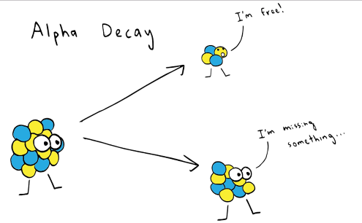
a. Alpha particle (α) is a helium nucleus (He-4), so it has a 2+ charge.
2 protons and 2 neutrons
b. Alpha emission is almost entirely restricted to very heavy nuclei.
c. Losing 2 protons means the element changes into a new element with an atomic number of 2 less on the periodic table.
2. Beta Emission (Beta Decay)
a. Beta particle (β) is an electron emitted from the nucleus during nuclear decay.
b. Beta particles are emitted when a neutron is converted into a proton and an electron.
c. A neutron becomes a proton and an electron (conservation of charge). The electron is ejected (the beta particle) and the proton remains in the nucleus.
d. Thus the mass number stays the same but the atomic number increases.
e. The atomic number changes to one more on the periodic table changing from one element to the next. Carbon is carbon because it has 6 protons, if it gains another proton to make 7 , it becomes nitrogen!

3. Gamma Emission (gamma decay)
a. Gamma rays (γ) are high-energy electromagnetic waves emitted from a nucleus as it changes from an excited state to a ground energy state.
b. Gamma rays are produced when nuclear particles undergo transitions in energy levels.
c. Gamma emission usually follows other types of decay that leave the nucleus in an excited state.
d. The atomic number changes to one more on the periodic table changing from one element to the next. Carbon is carbon because it has 6 protons, if it gains another proton to make 7 , it becomes nitrogen!
- Gamma rays are very high energy and are one of the most dangerous sources of radiation because photons can pass through most common shielding materials and cause DNA damage in living tissues.

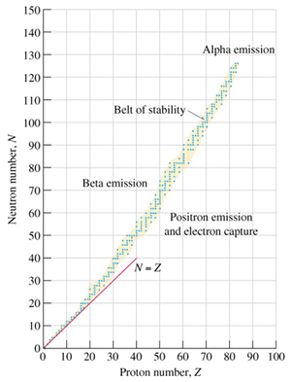
Pages 54 and 56
Nuclear Stability and Decay
A. Neutron-to-Proton Ratio determines the type of decay that occurs
1. Band of Stability
Half-Life (t_{1/2}) - The time required for half the atoms of a radioactive nuclide to decay
A. More stable nuclides decay slowly.
B. Less stable nuclides decay rapidly.

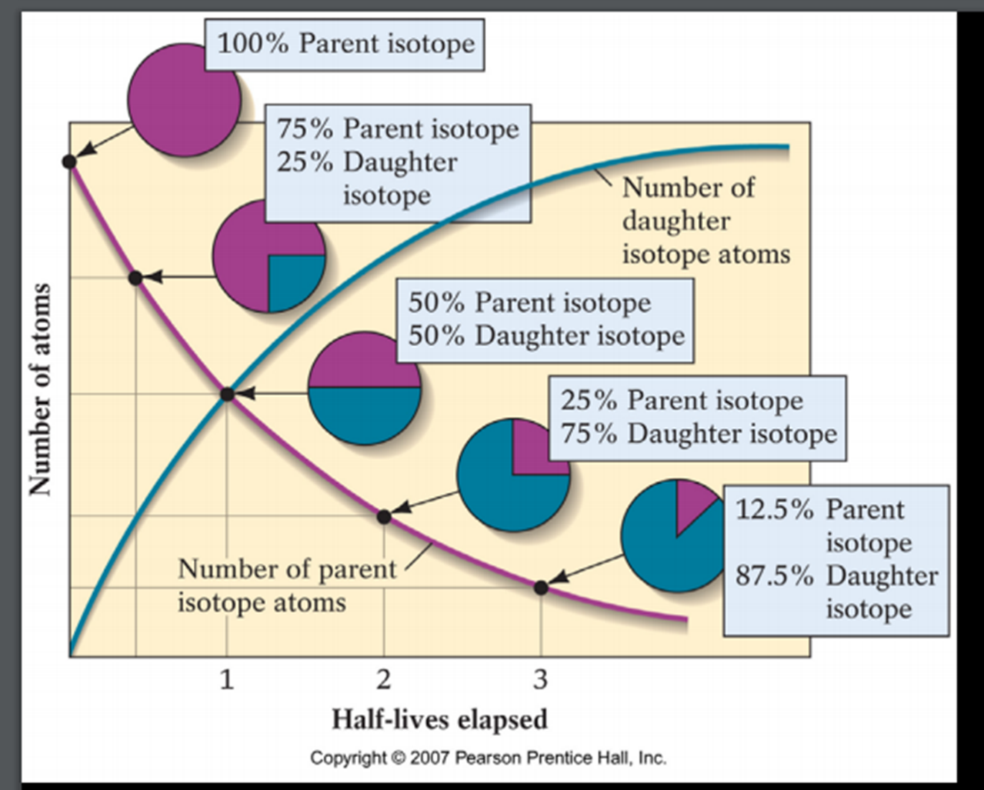

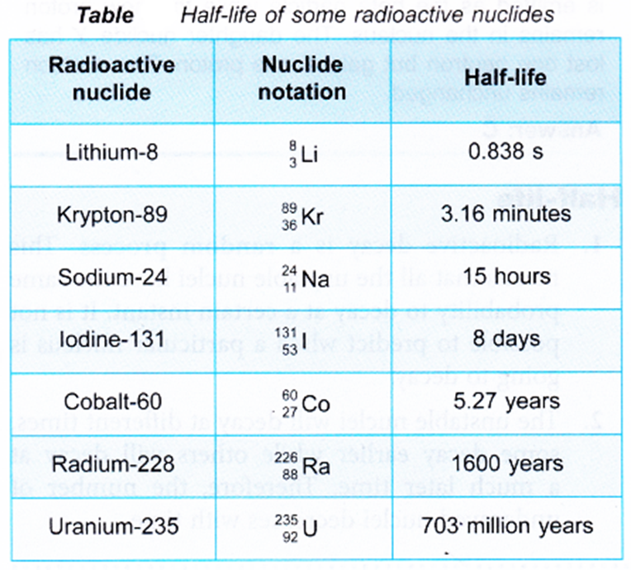
Transmutation Reactions
A. Transmutations - A change in the identity of a nucleus as a result of a change in the number of its protons
B. Nuclear Reaction - A reaction that affects the nucleus of an atom
- Small amounts of mass are converted to LARGE amounts of energy.
E = mc²
IV. Radiation in Your Life
A. Penetrating Ability
1. Alpha Particles
a. Least penetrating ability due to large mass and charge
b. Travel only a few centimeters through air
c. Cannot penetrate skin
d. Can cause harm through ingestion or inhalation
2. Beta Particles
a. Travel at speeds close to the speed of light
b. Penetrating ability about 100 times greater than that of alpha particles.
c. They have a range of a few meters in air.
3. Gamma rays
a. Greatest penetrating ability
b. Protection requires shielding with thick layers of lead, cement, or both

