Mysterious Ceres may hold clues about our solar system
By Los Angeles Times, adapted by Newsela staff
01/28/2014
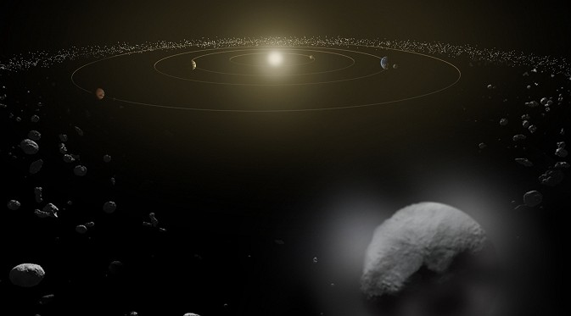

LOS ANGELES — It's hard to say just what Ceres is. It can be thought of as the largest known asteroid, or as the smallest dwarf planet. For a time in the 1800s, the rocky sphere was even considered a full-fledged planet.
Whatever it is, Ceres is looking more interesting these days. Astronomers have discovered water vapor steaming off the mysterious little planetoid. That discovery, published in the magazine Nature, could tell us something fascinating about the development of our solar system.
“Now we have really for the first time discovered water in the asteroid belt,” said lead author Michael Kuppers.
Ceres was the first asteroid to be discovered and is the largest one ever found. It sits in the asteroid belt between Mars and Jupiter — and it’s the only dwarf planet in the belt. It’s 590 miles wide and roughly spherical, which is why it was once considered a planet. It was massive enough for its own gravity to crush it into a more or less spherical shape.
But Ceres soon lost its title of planet when astronomers realized that its rocky body wasn’t alone: It was sitting in a vast field of rocky, lumpy bodies, or asteroids.

Ceres Packing A Lot Of Ice
Kuppers had been looking to do a little advance scouting before NASA’s Dawn mission visits Ceres next year. The major question hovering around the dwarf planet: Is it rich in water, or not?
Because Ceres isn't very dense, astronomers speculated that it could have a high amount of water, stored away as ice. Astronomers in the 1990s picked up signs of fragments of water molecules in the light coming from Ceres. However, a study in 2011 could not back that claim up.
To settle the matter, Kuppers and his team turned to the European Space Agency’s powerful Herschel Space Observatory. This enabled them to look for the signs of full water molecules, which gave them a much stronger signal. The team spotted clear signs of water coming from two separate dark spots. These were located on roughly opposite sides of the little world.
Water was coming off Ceres at a rate of 6 kilograms, or about 13 pounds, per second. That made the scientists think there could be a lot of ice packed in the dwarf planet’s mantle. So much, in fact, that if was melted it could add up to more fresh water than we have on Earth.
The scientists aren’t exactly sure how the ice is stored on Ceres or how it’s escaping as vapor.
It could be that heat from inside the planet is causing the water to rise up and explode into blasts of water vapor. It could also simply be that exposed ice on the surface in these two areas is melting and becoming vapor when the sun hits it. Water on Ceres wouldn't ever exist as a liquid, because liquid water requires a thicker atmosphere (like Earth's) to remain stable.

Planetoid Of Many Questions
Whatever is going on, the larger question remains: Why is Ceres so wet? And another puzzling question: Why is Ceres so different from the asteroid known as Vesta?
After all, Ceres is roughly the same distance from the sun as the lumpy asteroid Vesta, which is volcanic and bone dry. So how did Ceres hold onto this water when Vesta did not?
It turns out Ceres may not be native to this part of the solar system. It probably originated somewhere out past the “snow line.” Beyond this imaginary boundary in the solar system, water ice can exist in space, largely out of the reach of the sun’s rays to melt it.
Ceres may have been moved around during a major migration in the solar system’s history. Massive Jupiter, for example, is thought to have traveled toward and then away from the sun. Its gravitational pull yanked planets and asteroids around the solar system.
The icy asteroid also supports the idea that asteroids aren’t as dry as expected, Kuppers said. Icy comets are the usual suspect for having brought water to Earth. But, he said, it could just as well have been an asteroid.
Answering more questions about Ceres, and what it can tell planetary scientists about the solar system’s history, will have to wait. The Herschel Space Telescope, which is still in space, ran out of the coolant needed to keep its instruments working last year. But researchers won’t have to wait too long: NASA’s Dawn spacecraft reached Ceres in spring 2015 and gives scientists a close look at this strange, distant world.
“It’s exciting to see what Dawn is finding out,” said Kuppers.

