How a Chinese chemistry experiment became a U.S. Fourth of July tradition
By PBS NewsHour, 06/29/2017
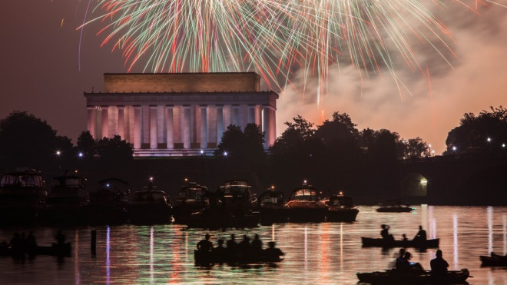
Fireworks were invented long before the United States used them to celebrate its independence. Sometime between A.D. 600 and 900, two Chinese scientists mistakenly mixed the chemical compound of potassium nitrate with sulfur and charcoal, creating a crude gunpowder. Legend has it that they were trying to create a drink that would help them live forever. What resulted was the first documented example of a firecracker.
"Fireworks were first just exploding bamboo tubes," said John Conkling. He's the former head of the American Pyrotechnics Association, a group that supports the fireworks industry. The Chinese got more and more creative over time, Conkling said. "[They] realized if you put other minerals in the basic material you could get different colors.”

The Main Ingredients for Fireworks
The basic firework requires three ingredients. It needs an oxidizer, a fuel and a chemical mixture to produce the color. An oxidizer is a type of chemical, usually oxygen, which causes fuel to burn. Without oxygen or an oxidizer, fuel will stop burning, which is why putting something over a candle will cause the flame to go out. Over the years, scientists have staged various chemical reactions to produce fireworks of different colors.
When different elements burn, they produce light at different wavelengths. Each wavelength corresponds to a certain color. For example, lithium and strontium carbonates produce deep reds and purples when they are burned. Copper chlorides produce blue. Titanium, aluminum and magnesium are silvery. Calcium chloride is orange, sodium is yellow and barium burns green. Because of copper’s narrow temperature range, blue is the most difficult color for pyrotechnic experts to create.

A Release of Energy Is Needed
Electrons are energy particles found in all forms of matter. When they are exposed to heat, they gain energy and change from their original state. "At high temperatures, an electron can get excited and jump to a higher energy level," said Conkling. “When it cools off, that electron drops back down to its normal energy state." In doing so, the electron loses the energy it had gained. This energy is released as light, with a certain wavelength. The color of that light depends on what chemical elements are present.
A firework is ignited by lighting a main fuse, which kicks off the chemical reaction inside. The flame travels through the lift charge, the first blast of powder that sends the firework upward. As it flies through the air, potassium nitrate, charcoal and sulfur combust. They heat the main casing of the firework. When the casing explodes, pellets containing the chemical color mixtures fly out. As they fall to the ground, they release energy in the form of light. This produces the glittering firework shape we see.
“In the old days, someone with a torch would walk along the line of the mortars and individually light the fuses for the shells. It certainly limited the artistry [based on] how fast that guy could run,” Conkling said. Today, most fireworks are not physically lit. Instead, people use electricity to light them from far away.

