Chapter 22 Nuclear Chemistry
22.I. The Nucleus
Essential Questions:
- What is a nuclide? How can nuclides be represented?
- Can you relate the terms ‘mass defect’ and ‘binding energy’?
- Why do nuclear reactions occur?

I. Mass Defect and Nuclear Stability
A. Nucleons are neutrons and protons.
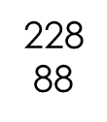
B. Nuclides are atoms identified by the number of protons and neutrons in the nucleus
a. radium-228 or Ra
C. Mass defect- the difference between the mass of an atom and the sum of the masses of its protons, neutrons, and electrons.
D. This lost mass can be accounted for.
E. Albert Einstein’ equation
E = mc²
(energy =mass x the speed of light [300,000 km/s]²)
means mass can be converted into energy and energy can be converted into mass.
F. The lost mass has been converted in this manner to the nuclear binding energy. This is also related to how stable the nucleus is.
II. Nuclear Reactions
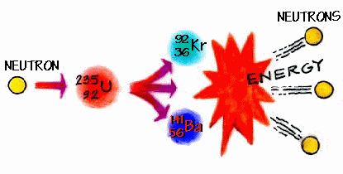
A. Unstable nuclei undergo changes that change the number of protons and neutrons
B. During these changes they give off large amounts of energy and therefore increase their stability.
C. This is called a nuclear reaction because it is a reaction that affects the nucleus of an atom.
D. When the number of protons changes, the identity of the atom changes this is called transmutation.

