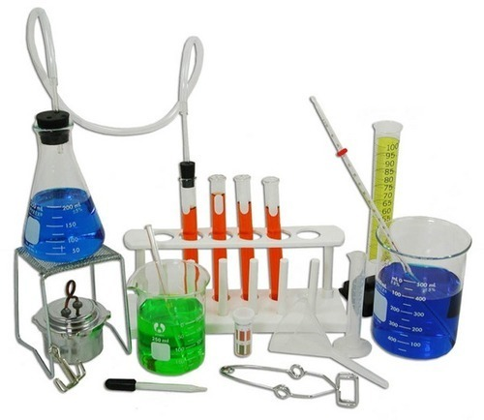

Name as many objects in the picture that you can.