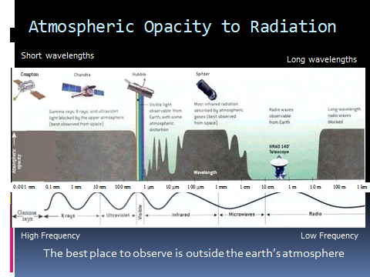
0.001 nm 0.1 nm 1 nm 10 nm 100 nm 1 μm 10 μm 100 μm 1 mm 1 cm 10 cm 1 m 10 m 100 m 1 km
Visible
Radio
Microwaves
Infrared
Ultra-violet
X rays
Gamma
Rays
Wavelength
Atmospheric
Opacity
Compton Chandra Hubble Spitzer
NRAO 140° Telescope
Long wavelength radio waves are blocked
Radio Waves observable from Earth
Most infrared radiation absorbed by atmospheric gases (best observed from space)
Visible light observable from Earth with some atmospheric distortion
Gamma rays, X-rays and ultraviolet light blocked by the upper atmosphere (best observed from space
Assignment:
- Draw the picture on your own paper!
- Annotate the picture with the answers to these questions
  - What type of energy does this graphic show?
  - What does ‘opacity’ mean?
  - What does the shaded part mean
    - If it is shaded all the way
    - If it is shaded partway
    - If it is NOT shaded
  - There are five (5)telescopes drawn on the graphic
    - What are their names?
    - What type of waves do each detect?
    - Why are 4 telescopes outside the atmosphere in space and 1 is on the ground?
  - There are numbers from 0.001 nm to 1 km- what do those numbers mean?
  - Frequency and wavelength go together
    - What makes a high frequency?
    - What makes a low frequency?
  - How are the waves organized?
  - What speed do all these waves travel?

