1. **ROCKET BODY**
   1. Carefully cut out all pieces.
   2. Roll the main rocket body (1. Rocket tube) with the text rolled up inside to strengthen the tube. *CAP Rocket Program and a few important lines will be on the outside*. Glue into shape.  
                Tip: Roll the tube around a spent engine to see how the lines on either side of the CAP seal meet.

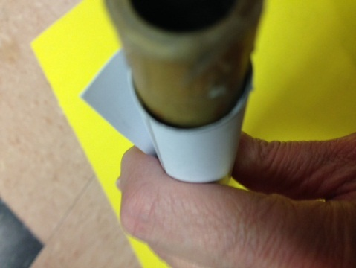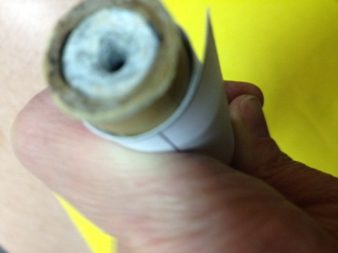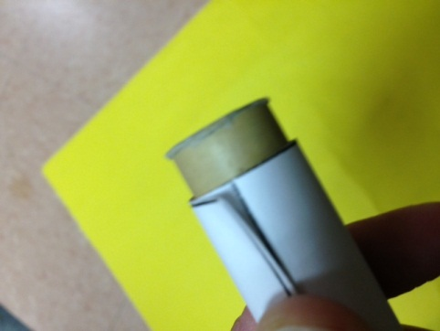

The tube should fit snugly around the rocket engine; this picture shows a gap that is too large

The edge of the paper should come up to the line as shown in this picture.

This is tight enough

1. **ENGINE STOP RING**

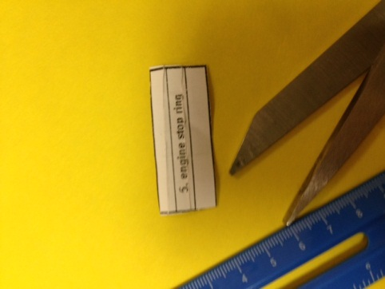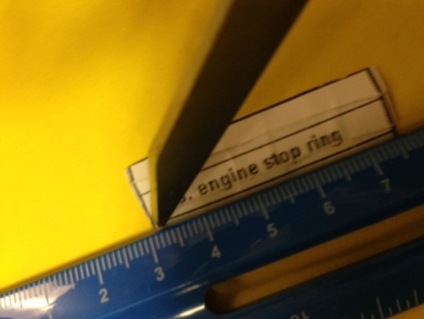 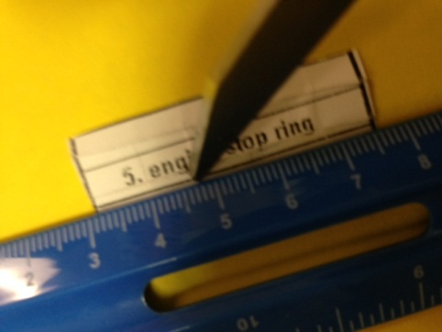

Score the “engine stop ring”.

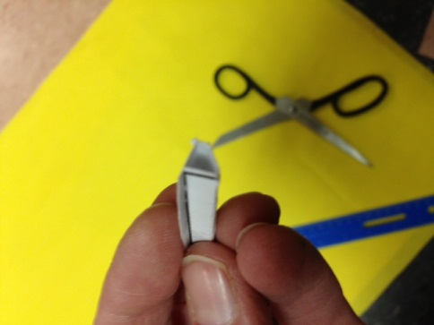 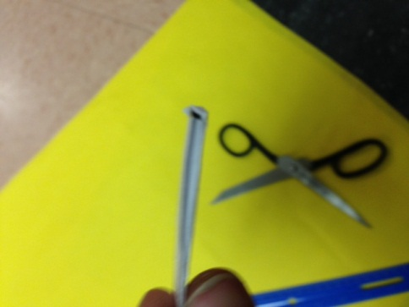 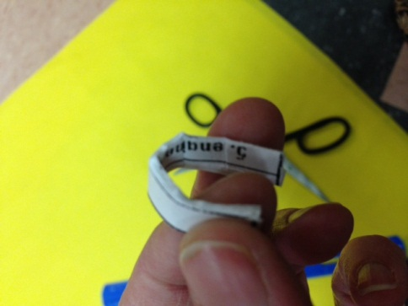

Tri fold and glue (5. engine stop ring) and shape into ring (it is more like a “C”). With a long piece of the cardstock from your scraps, apply a ring of glue 2.5 inches inside the bottom of tube. This is the exact length of the engine.

Use a stick push the engine ring into position, and press it into place against tube body with a stick

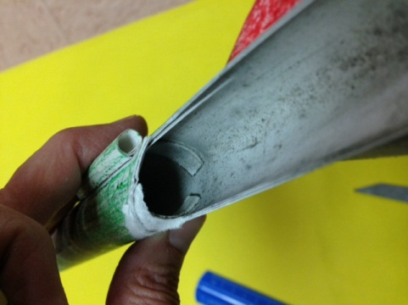 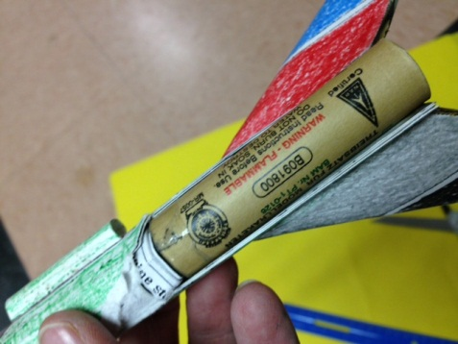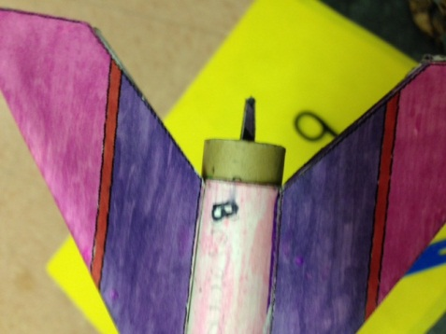

This is a cut-a-way view inside a rocket. The Engine stop ring is glued inside the tube

Be sure the distance of the stop ring from the end is exact; too close and the engine sticks out, another mistake.

Stop ring

Stop ring

The ring is exactly the length of the engine away from the edge. Glue the ring in tightly. A loose stop ring will cause your rocket to burn up.

***The cuts are so you can see the inside***

**DO NOT CUT YOUR ROCKET LIKE THIS**

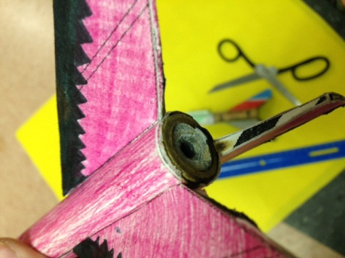

This is a perfectly placed stop ring and the engine sits just at the edge.

1. **FINS**
   1. 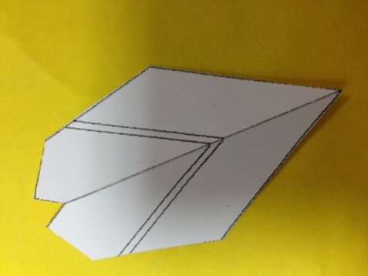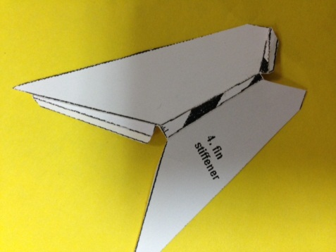Cut out three fin stiffeners (4) and three fins (3)
   2.  Score the fin stiffeners along 6 lines

Score

Score

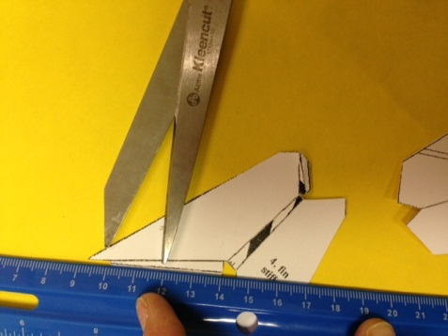

Score

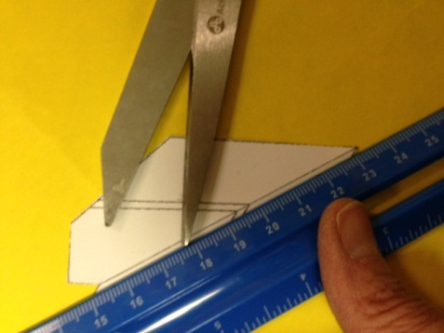

Score only the middle line, and then fold it.

* 1. 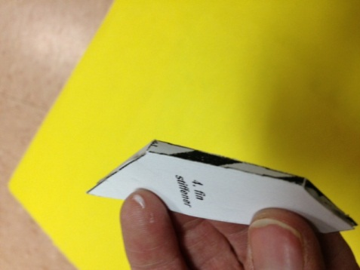Score and fold all three (3. fin) in half along leading edge.

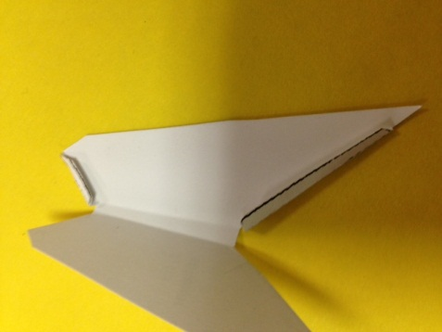

Black stripes

Glue

* 1. Fold (4.fin stiffener) along score lines and tack with glue along tabs to make the wedge shape.  
               Note: black stripe area will become the trailing edge of fins.
  2. 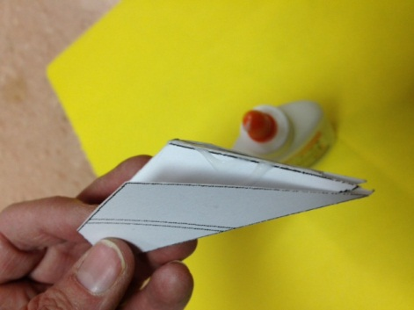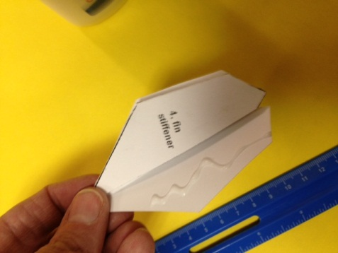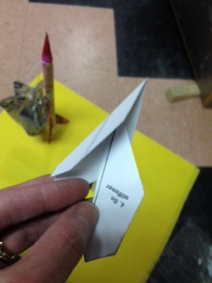Smear thin coat of glue to entire back side of (3. fin) and insert (4. fin stiffener).
  3. You will have 3 fins when finished.

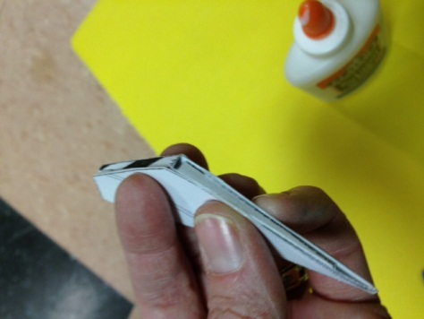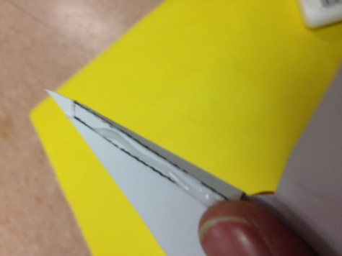

Glue

1. 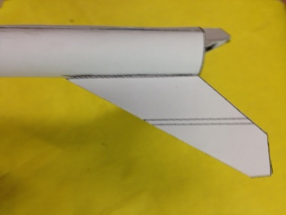**ATTACH FINS TO ROCKET** **TUBE**

**RIGHT**

Glue

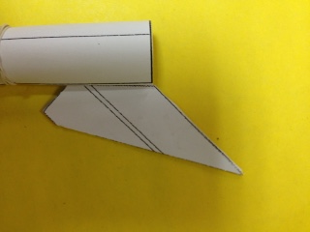

**WRONG**

**120 °**

* 1. Put glue on the ***white*** edge of the fin

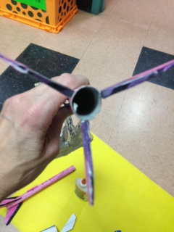

* 1. 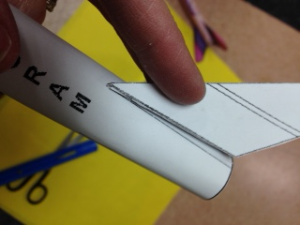Glue one fin to each of the lines on the rocket body, and on the seam where it is glued.

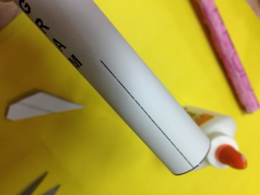

Fin line

* 1. 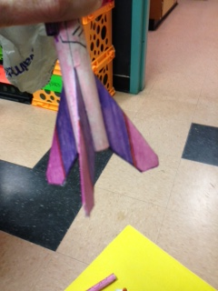The fins are 120 ° apart
  2. Dry upside down in the racks so the fins aren’t deformed.

1. **NOSECONE**
   1. Cut out these pieces
   2. 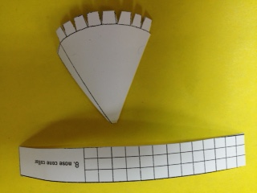***DO NOT SCORE!***
   3. Gently begin to curve them
   4. Glue cone first

Glue opposite edge to this line

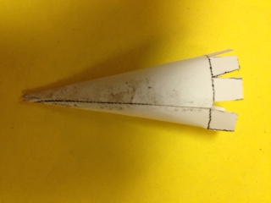

Keep the bottom edge even as you glue

* 1. Decide if you want the nose cone collar to go inside the rocket tube or outside the tube.
  2. 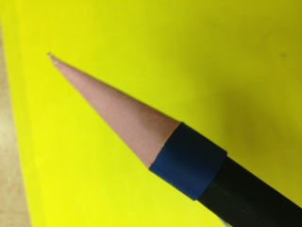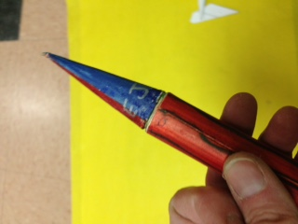It makes no difference in the way it flies.

Outside

Inside

* 1. If inside, roll up the collar and be sure if fits snugly inside the tube at the top of the rocket. It should not be so loose that it falls off, but also not so tight that you can’t get it off.

Roll the words inside; you need the layers to strengthen it.

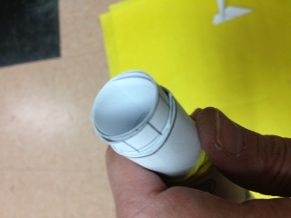 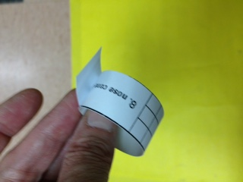

No gaps

* 1. If outside, roll the collar around the outside of the top of the rocket. Again, it should be snug, but not too loose or too tight.

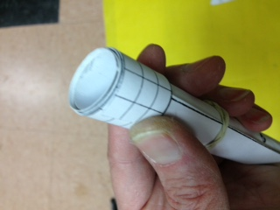

* 1. Glue the collar together both the inside flap and the outside flap.
  2. 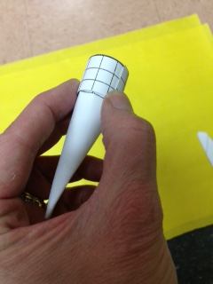Next glue the nose cone to the collar.
  3.  For both the inside collar and outside collar the nose cone flaps should be tight and flat against the ***inside*** of the collar so you can see all the way to the point.

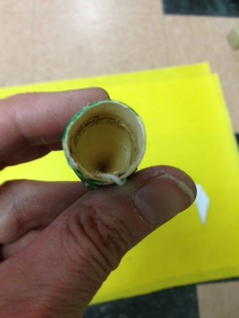

Flaps

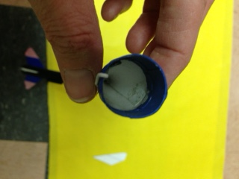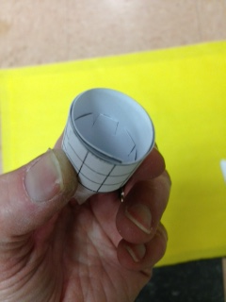

* 1. ***DO NOT GLUE THE FINISHED NOSE CONE TO THE ROCKET BODY!! IT REMAINS SEPARATE.***

1. **LAUNCHING LUG**

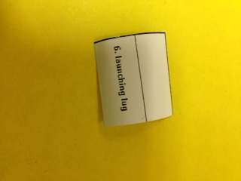Construct and attach the launching lug. The launching lug is a little tube attached to the side of the rocket that slides on the launching wire to keep the rocket straight as it begins its flight. ***. DO NOT MAKE TH E LUG TOO TIGHT!***  If the lug is too tight, it sits on the wire and explodes on the launch pad, no fun.

* 1. Cut out the lug
  2. DO NOT SCORE THIS PIECE!
  3. 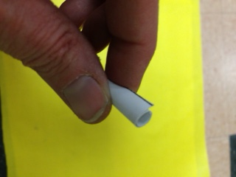Roll the lug into a little tube.

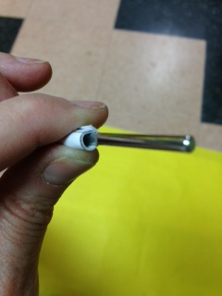

* 1. Make sure the tube fits on the wire and can slide ***easily*** without wobbling.

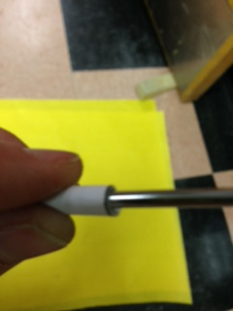

Not to tight or too loose

* 1. 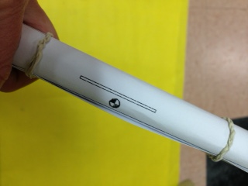Once you have determined how big it should be, glue it together and glue it onto the rocket. There is a line on the rocket indicating where it should be attached.

Attach here

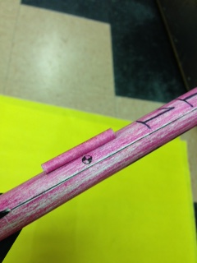

Glued to rocket

* 1. 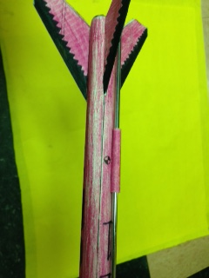This picture shows the lug attached to the rocket and slid onto the launching wire.

lug

wire

* 1. If you slide the assembled rocket onto the wire and it doesn’t slide well or gets stuck, it is too tight and you need to make a new lug or fix the one you have.

1. 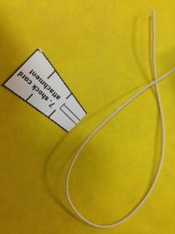**SHOCK CORD ATTACHMENT**
   1. You will need the 2 shock cord attachment pieces, and a piece of elastic cord

32

* 1. Glue the end of the cord in the little box on the narrow end and fold on the fold line as shown
  2. Add more glue and fold the piece a second time
  3. 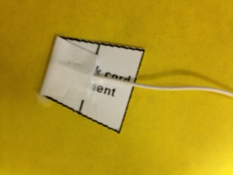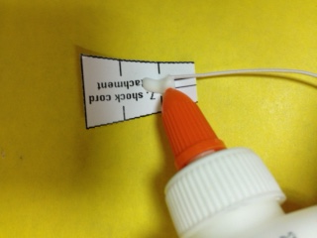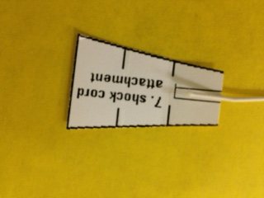Do the same on the other end of the cord

33

33

33

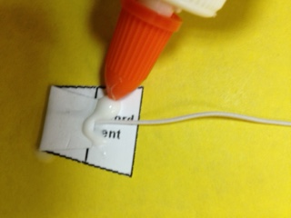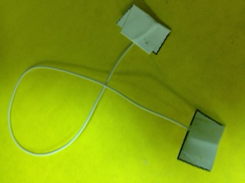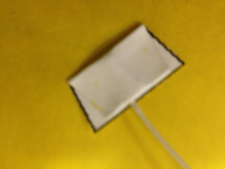

35

34

34

1. **GLUE THE SHOCK CORD TO BOTH THE NOSE CONE AND ROCKET BODY**
2. If your nosecone fits INSIDE the rocket body you need to glue the attachment piece far enough down the ***rocket tube*** so it doesn’t interfere with the fit of the nose cone
3. The attachment in the ***nose cone*** can be close to the edge, since it doesn’t interfere with the fit.

***\*Be sure to flatten the attachment pieces as close to the wall of the rocket as you can!***

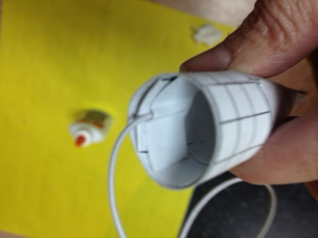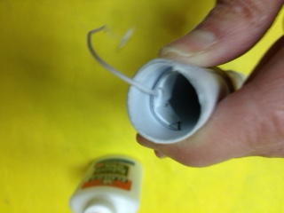

**INSIDE FIT**

ROCKET BODY

NOSE CONE

1. If your nosecone fits OUTSIDE the rocket body you need to glue the attachment piece far enough inside the ***nosecone*** so it doesn’t interfere with the fit of the nose cone.
2. The attachment in the ***rocket body*** can be close to the edge, since it doesn’t interfere with the fit.

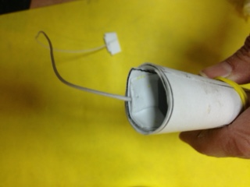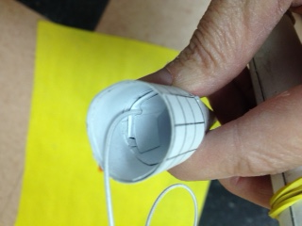

**OUTSIDE FIT**

ROCKET BODY

NOSE CONE

1. 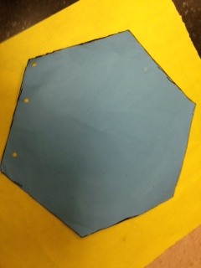**MAKE A PARACHUTE OR STREAMERS**
2. Get a parachute pattern, the blue or brown butcher paper hexagons

Parachute pattern

1. Use the pattern and cut a parachute out of the plastic bags I provided
2. 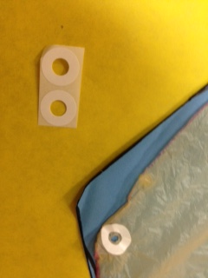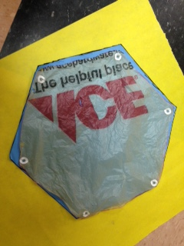Put a reinforcing sticker (the little circles) on each corner of the parachute and use scissors to poke a hole in the plastic.

reinforcers

1. Cut 3 strings about 30cm long and tie them through the holes.
2. Be sure to make a loop and tie a knot and put a drop of glue on the knot (*Let the glue dry thoroughly*!)
3. 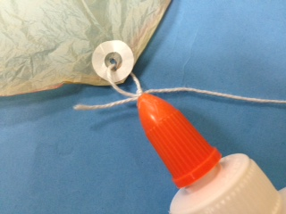Both ends of the string will be tied through holes so you have 3 loops (*see picture*)

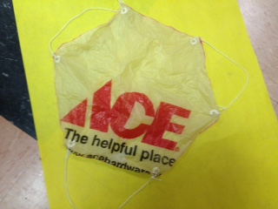

44

1. 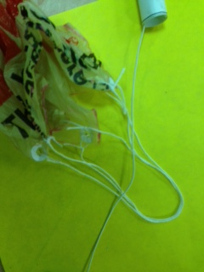**ATTACH THE PARACHUTE TO THE SHOCK CORD**

46

1. Take all 3 loops of the parachute (or the single loop of the streamers) and pass them ***UNDER*** the shock cord

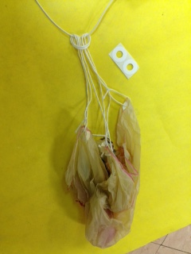

1. 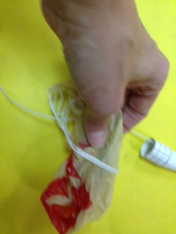Take the parachute in one hand and pass it ***OVER*** the shock cord and ***THROUGH*** the loop. Pull it tight. Glue the knot about 3-4 cm from the ***NOSECONE.***

47

1. **DECORATE THE ROCKET**
2. Use paint, crayons, or markers to decorate the rocket.
3. **WEIGHT THE NOSECONE**
4. Add clay into the nose cone to give it some weight to help it fly straight
5. 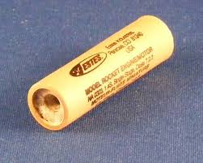**LOAD THE ROCKET FOR LAUNCH**
6. Insert your engine into the rocket near the fins.
7. Be sure the end with the small hole is visible

This end showing

1. From the top load the recovery wadding.
2. Carefully fold the parachute. **DO NOT ROLL!!**
3. Stuff the parachute carefully inside the rocket body
4. Replace the nose cone. See diagram

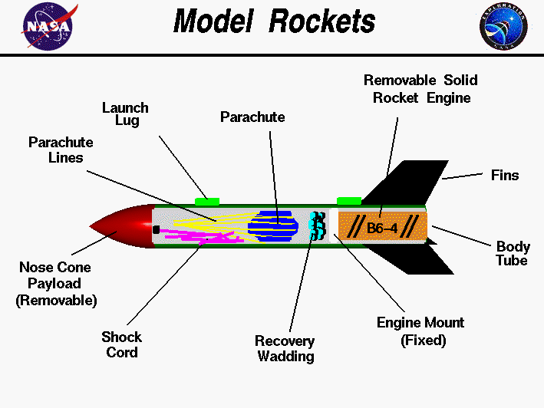

1. 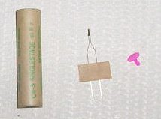**INSERT THE IGNITER**
2. Take the igniter and the plastic plug from your teacher. Be gentle with the igniter, broken ones don’t work and they are expensive.
3. Carefully insert the narrow end into the small hole in the rocket engine; GENTLY fold the taped end over so it is OPPOSITE from the launching lug. ***DO NOT TWIST THE IGNITER!***
4. Insert the plastic plug to hold the igniter in the engine.
5. READY TO LAUNCH!

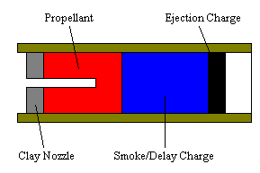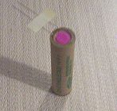

Insert igniter here

