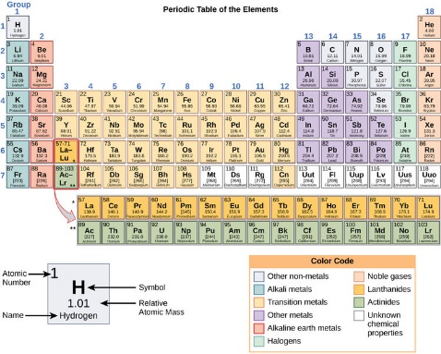
830L

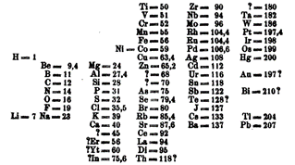
The periodic table: A classic design
By Mark Blaskovich, 01/01/2018
The periodic table is hanging on the wall of many science labs and classrooms. Almost everyone has seen it at some time in their life. You can also find the periodic table on T-shirts, mugs, beach towels and plenty of other items. People have even written short stories and songs about it.
New elements keep being added to the periodic table over the years. The periodic table is an attempt to organize the elements that make up the universe. An element is a certain type of atom. Atoms are tiny parts that make up all matter in the universe.
The Elements
Scientists began collecting elements 300 years ago. They slowly found new ones over the years and noticed that some of them had similar behavior. Some were gases, some were shiny metals, some reacted violently with water, and so on.
Scientists began to group similar elements together. It's the same as when a person collects seashells and organizes them by shape or color. But many elements were still unknown. This left gaps that made finding patterns a bit like trying to solve a puzzle with missing pieces.
Mendeleev's periodic table. Image: Dimitri Mendeleev/Wikimedia.
Different scientists came up with different types of tables. The first version of the table we use today was made by Dmitri Mendeleev almost 150 years ago. He was a Russian chemistry professor. Mendeleev left gaps in the table where he thought missing elements should be placed. Over time, other scientists filled in these gaps.
The Atoms
To understand the periodic table, we need to understand atoms. Atoms have a core in the middle called the nucleus. It is made up of smaller particles called protons and neutrons. The number of protons is called the element's atomic number. This number is found in the top left corner of each box in the periodic table.
The periodic table is organized from the smallest to the largest atomic number. The number goes up as you read left to right, top to bottom. Element 1, called hydrogen and written as H, is in the top left. The newly discovered element 118, called oganesson or Og, is in the bottom right. Atoms of the same element with different numbers of neutrons are called isotopes.
The Electrons
An atom is not just made of protons and neutrons. It also has electrons, which move around the nucleus. An atom can have up to seven layers of electrons, called shells. Each shell gets filled in a certain order as electrons are added. Each row in the periodic table matches up with one of these shells.
Elements in the last column, such as helium and neon, are called the noble gases. They are all gases, and they are "noble" because they rarely connect with other elements.
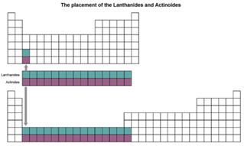
The elements of the first column, except for hydrogen, are called alkali metals. The elements in this first column are metal-like and connect very easily with other elements.
The first shell only fits two electrons, so the first row of the periodic table has only two elements: hydrogen (H) with one electron, and helium (He) with two. The second shell fits eight electrons. That's why the second row of the periodic table contains eight elements.
As the atoms get bigger, they can hold more electrons, so the rows get longer, too. Sometimes electrons get added to an outer layer before all the inner layers are full. That is why there are gaps in the table.
There are also two rows below the main table. They are there because the table would be too wide to read otherwise.
The periodic table would look very different if the extra rows were added. Image: The Conversation.
Across The Columns
Each shell is made up of parts called subshells. As the electrons are added to each layer, they go into different subshells.
Elements in the same column usually behave in similar ways. In some places, elements side by side can also be similar. Most of the elements with high atomic numbers are very unstable. They have never been found in nature. Instead, tiny amounts are created and studied in labs. There could be more elements beyond the 118 we know today. We just haven't found them yet.
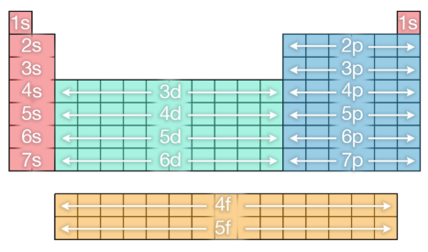
Shells marked on the periodic table. Image: The Conversation
A Classic Design
There are many colorful and informative versions of the periodic table. One of my favorites is an artistic version with original artworks for each element. Another is an interactive version with pictures of the elements.
The design of the periodic table can be used to play a version of the Battleship game. There are also fun versions created to help organize many different objects, including food, emojis and birds.
The periodic table is the guide to all the elements. It is very important to scientists, but has also become part of popular culture.
Mark Blaskovich is a chief scientist at the University of Queensland, Australia.

