550L
The periodic table: A classic design
By Mark Blaskovich, 01/01/2018
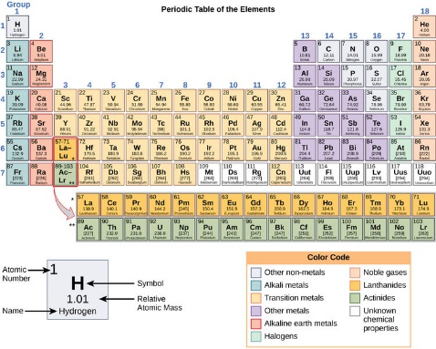
Almost everyone has seen the periodic table. It is hanging on the wall in many labs and classrooms. Or, you may have seen it on T-shirts and mugs. People have even written stories and songs about it.
The periodic table shows all the elements we know of. An element is a basic type of matter. Everything in the universe is made up of elements. As scientists discover new elements, the periodic table gets bigger.

The Elements
Scientists began collecting elements 300 years ago. They noticed that sometimes different elements behaved the same way. Some were gases, for example. They floated in the air and had no shape. Others were shiny metals.
Scientists began to group the elements together. It was like collecting rocks and organizing them by shape or color. Back then, not all the elements were known. This left gaps. It was like trying to put together a puzzle with missing pieces.
Mendeleev's periodic table. Image: Dimitri Mendeleev/Wikimedia.
Different scientists came up with different types of tables. The one we use today was made by Dmitri Mendeleev almost 150 years ago. He was a Russian chemistry professor.
Mendeleev left gaps in the table. He thought missing elements should be placed there. Over time, other scientists filled in these gaps.
The Atoms
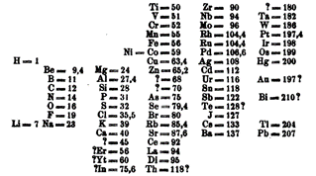
All matter in the universe is made of tiny parts called atoms. Each atom is a certain element. The middle part of the atom is called a nucleus. This nucleus is made of even smaller parts. These parts are called protons and neutrons.
Each box in the periodic table is a different element. The top left corner of every box has a number. This is called the "atomic number." It tells you how many protons an element has. The atomic number goes up as you read left to right, top to bottom. Atoms of the same element with different numbers of neutrons are called isotopes.

The Electrons
Atoms do not just have neutrons and protons. They also have electrons. These parts move around the nucleus. An atom can have up to seven layers of electrons. These layers are called shells.
Each shell gets filled with electrons in a certain order. Each row in the periodic table matches one of the shells. Elements in each column have common traits. Elements in the last column are all gases. They usually don't connect with other elements.
The elements of the first column, except for hydrogen, are called alkali metals. These elements are metal-like. They connect very easily with other elements.
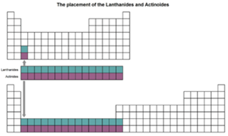
There are also two rows below the main table. They are there because the table would be too wide to read otherwise.
The periodic table would look very different if the extra rows were added. Image: The Conversation.
Across The Columns
Each shell is made of many subshells. As the electrons are added to each layer, they go into different subshells. The periodic table shows how these subshells get filled out. As electrons are added, the elements go from left to right.
Most of the elements with high atomic numbers have never been found in nature. These were created by scientists. There could be even more elements than the 118 we know today. We just haven't found them yet.
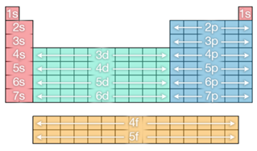
Shells marked on the periodic table. Image: The Conversation
A Classic Design
The periodic table is very famous. Many people have made their own versions of it. One of my favorite periodic tables had artworks for each element. There are also fun ones. Some were made to help organize different things like food, emojis and birds. The periodic table can also be used to play games like Battleship.
The periodic table is the guide to all the elements. It is very important to scientists. It has also become part of popular culture.
Mark Blaskovich is a chief scientist at the University of Queensland, Australia.

