Notebook covers:
Criteria for the notebook covers:
- The Title of the class must be bold and easy to read
- Your FULL NAME must appear on the cover, again easy to read.
- Please put this statement on the cover as well:
  - If Lost, Please Return To B-201, Mrs. Seslar’s Class
- You should illustrate the cover with pictures that represent what the class means to you. The illustrations should take up the whole cover. (1 or 2 large pictures or several small ones)
  - You can draw them
  - Cut them out of a magazine
  - Print them off the computer
  - Design and print the whole cover on the computer.
- The cover should be colored with at least 5 colors.
- Write 5 key words, or important words, or vocabulary words on the cover along with the pictures.
LOOK AT THE EXAMPLES, GOOD EXAMPLES BUT ALL NEED IMPROVING IN ONE OR MORE AREAS.
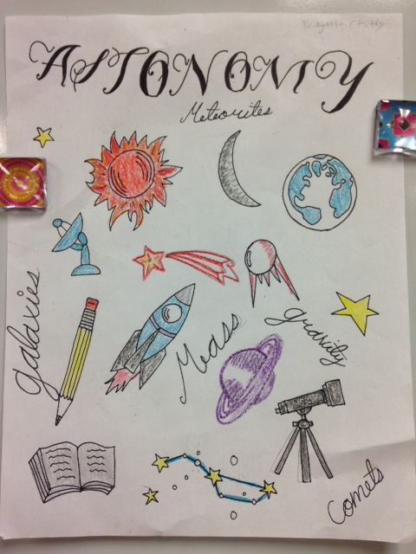
The student’s name is hard to read, otherwise great! Again, no name.

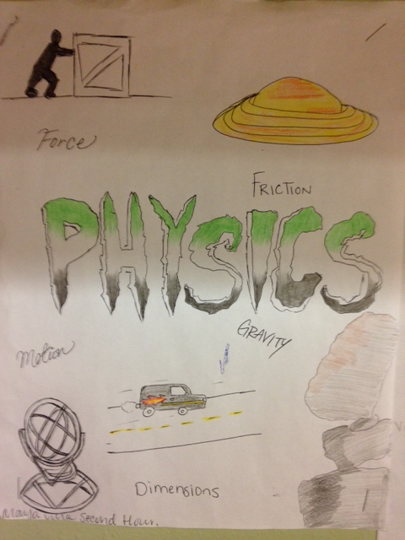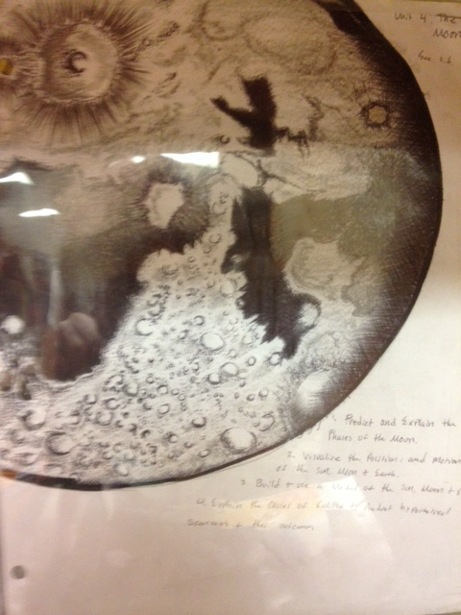
Student name could be bigger. Not in color but the shading makes up for it. Needs title
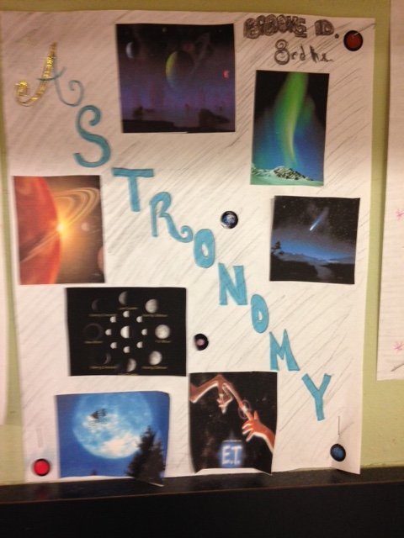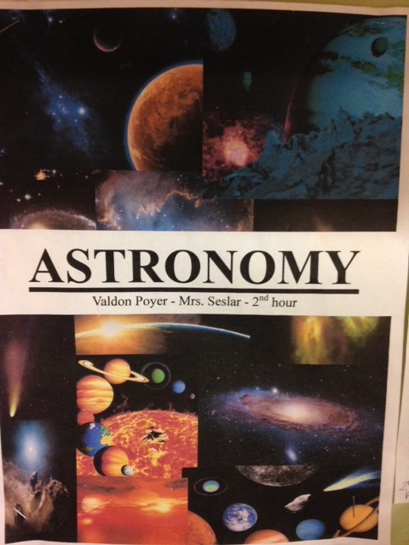
Nice cut out pics, missing words. Designed on computer nicely, but again no words.

